School of Engineering

**The University of British Columbia | Okanagan**

#### ENGR 454: Motor Drive Systems

Student 1 name: ______________________________

Student 2 name: ______________________________

**Maximum two students form one team!**

##### Design Project: Brushless DC motor drive with speed regulation

**Objective:**

1. **Design a brushless DC motor drive system with 180° and sine-triangle PWM modulations.**
2. **Tune a proportional and integral controller (PI) for motor speed regulation in motoring and regenerative modes.**
3. **Use Simulink/Simscape/Power Systems/Specialized Technology to verify the design of the brushless DC machine drive system**
4. **Design the three-phase inverter for the brushless DC machine drive by sizing the DC-link voltage**

**Project Report Due: Fri. Apr. 10, 10pm, 2020**

**Instructions:**

There are four tasks to this project corresponding to the project objective. The computer simulation in Simulink/Simscape/Power Systems/Specialized Technology plays an essential role completing the four tasks. Complete the four tasks in the space provided in the document and attach additional documentation/results as required. **This document will be your project report. Therefore, please provide enough information such as calculation procedure, Matlab code, simulation results/waveforms, question comments, and a conclusion in this report.**

Design a brushless DC motor drive for drone application. A four-pole, three-phase permanent magnet synchronous motor with the following parameters are given as $r_{s}=3.4Ω$, $L_{ls}=1.1mH$, $L_{ms}=11mH$, the rotor permanent magnet flux $λ_{m}=0.2 V∙s/rad$, the shaft inertial $J=5×{10}^{-4}kg∙m^{2}$. The **peak** motor torque $T_{e}$ that the brushless DC motor should develop is $1N∙m$. The rated speed of the motor is $400rpm$. The brushless DC motor is supplied from a battery with the rated DC voltage of 72V. The brushless DC motor should be able to operate with controlled speed from 0 to 600 rpm in motoring and regenerative modes with the peak torque $T_{e}=1N∙m$ or $T_{e}=-1N∙m$.

Task 1: Design a Brushless DC Motor Drive with 180° and sine-triangle PWM modulations

In the first task, we need to design a brushless DC motor and its three-phase inverter with 180° and sine-triangle PWM modulations.

(1). The speed regulation requires that the motor torque $T_{e}$ is controlled by the three-phase inverter output voltage $V_{qs}$ as given in the torque equation in Lecture 11 PPT. Recall that $V_{qs}=\sqrt{2}V_{s}$, i.e., the peak value of the supplied three-phase AC voltage, given the initial supplied voltage angle $ϕ_{v}=0$ in Lecture 10. Therefore, we will need to control the peak value of the output fundamental frequency AC voltage. This can be achieved in the three-phase inverter by controlling the DC-link voltage or using the pulse width modulation (PWM) of the three-phase inverter. To vary the DC-link voltage is not as straightforward as the use of PWM of the three-phase inverter. Therefore, in this project, we adopt PWM control instead of varying the DC link voltage.

In the first step, we will implement the three-phase inverter with 180° modulation and its PWM control. It is noted that the 180° modulation has already been introduced in Lecture 4 PPT. However, the PWM operation of the 180° modulation is not introduced in the lecture yet. The fundamental principle of the PWM operation of the 180° modulation is given below.

**180° modulation with its PWM control**

Figure 1 illustrates the logic control strategy for 180° modulation with its PWM control. Therein, the logic signals S1–S3 are the same as the switching signals T1–T3 for 180° modulation operation. The control input to the converter is the duty cycle *d*, which may be varied from 0 to 1. The signal *w* is a triangle waveform that also varies between 0 and 1. The duty cycle *d* and triangle wave *w* are inputs of a comparator, the output of which will be denoted *c*. The comparator output is logically added with S1–S3 to yield the control signals for the semiconductor devices.

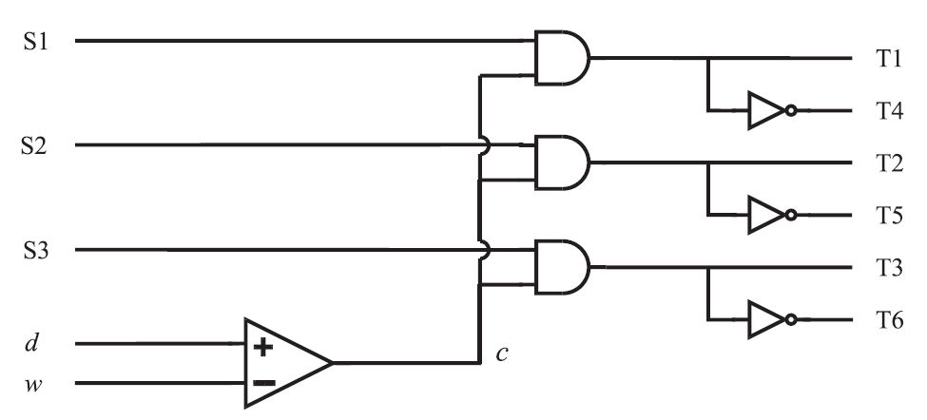

Figure 1. 180° modulation with its PWM control

The operation of this control circuit is illustrated in Figure 2. The signals S1–S3 are identical to T1–T3 in 180° modulation. The duty cycle *d* is assumed to be constant or to vary slowly relative to the triangle wave. The frequency of the triangle wave is the switching frequency *f*sw (the number of times each switching device is turned-on per second), which should be much greater than the frequency of the fundamental component of the output. The output of the comparator *c* is a square wave whose average value is *d*. When *c* is 1, the switching signals to the transistors T1–T3, and hence the voltages, are all identical to those of 180° operation. When *c* is 0, all the voltages are zero.

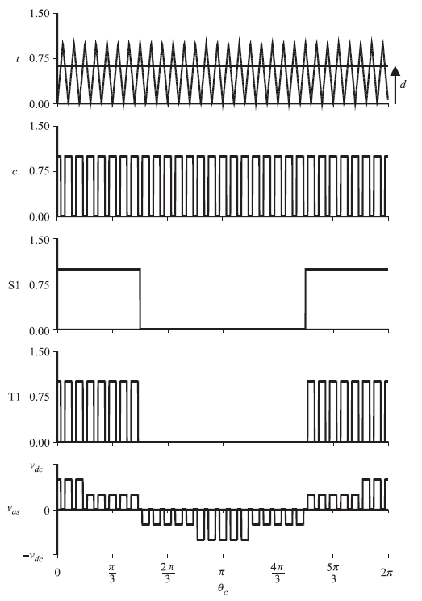

Figure 2. Waveforms of 180° modulation with its PWM control

You can use the example model – project_180PWM_example to implement the three-phase inverter with PWM controlled 180° modulation. **The block for the PWM signal generation is already provided in the example model. You will need to connect it to the gating signal generation as in Figure 1.** It is assumed that the duty ratio $d=0.6$, the PWM (triangular wave) carrier frequency *f*sw = 1kHz, and the motor mechanical torque is $T_{m}=1N∙m$, run the simulation from 0 to 1 second.

Please show in the space below (you can enlarge the space) that how the 180° modulation with PWM control is implemented in Simulink/SimScape/Power Systems/Specialized Technology. (attach the model implementation screen snapshot). Plot the six gating signals from T1 to T6 in one figure with six subplots from 0.85 s to 0.95 second., the stator currents $i_{qs}$, $i_{ds}$ in one figure with two subplots, $i_{as}$, $i_{bs}$, and $i_{cs}$ in one figure, the motor torque $T_{e}$ in one figure, the motor speed $N$ rpm in one figure, and inverter output line to line voltage $v_{ab}$ from 0.85 second to 0.95 second in one figure. Vary the duty ratio $d$ from 0.4 to 1 and comment what you have observed.

The gating signal T1 for 180° modulation with PWM control is shown in Figure 3 the motor electromagnetic torque $T_{e}$ can be obtained from the simulation as shown in Figure 4.

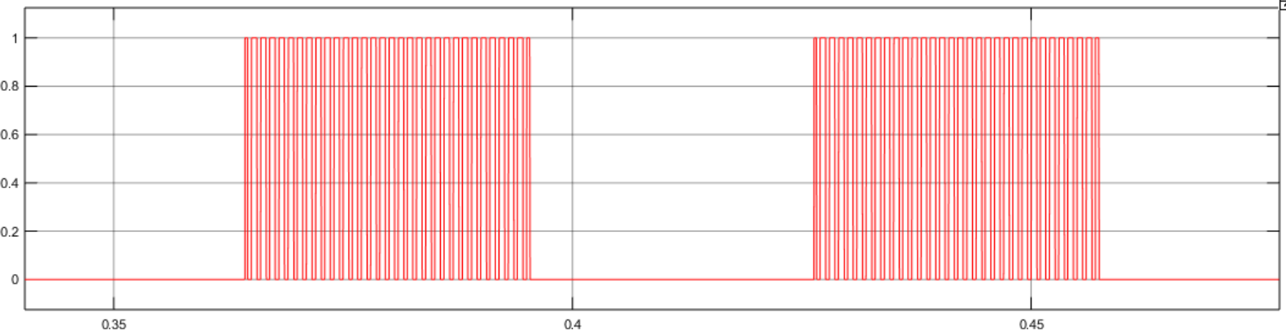

Figure 3 Gating signal T1 for 180° modulation with PWM control

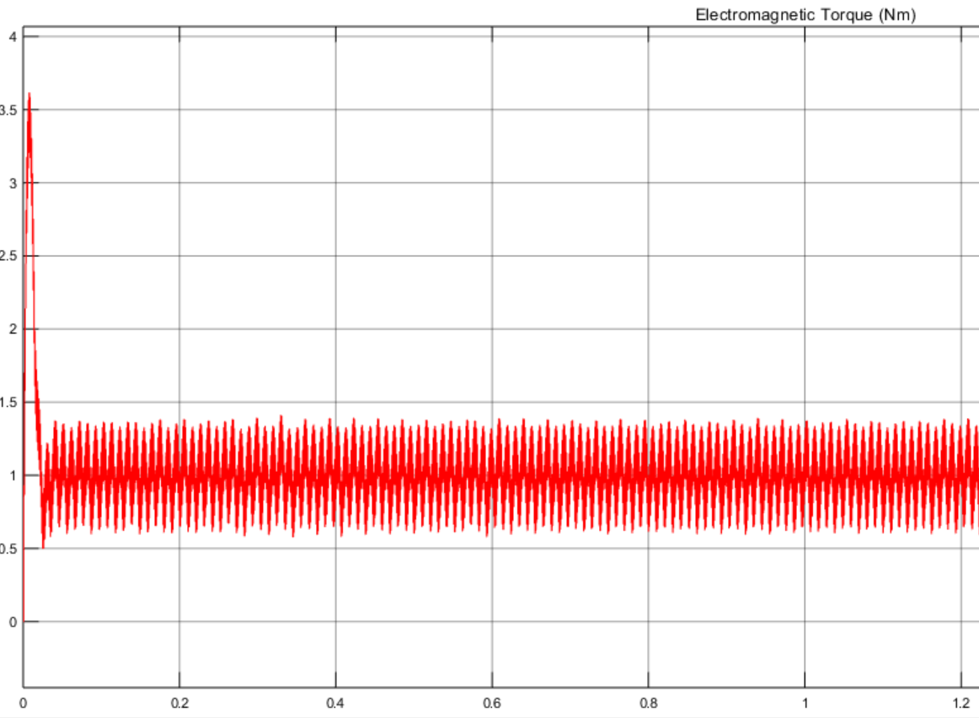

Figure 4 Motor electromagnetic torque for 180° modulation with PWM control

(2). It is observed in Figure 4 that the motor torque ripple is large due to the voltage harmonics in the three-phase inverter output voltages. If we requires smaller torque ripple, the sine-triangle PWM can be used instead of the 180° modulation with PWM control. You can use the example model – project_sinePWM_example to implement the three-phase inverter with sine PWM modulation. In the example model, assuming the sine modulation wave $m=\hat{m}cos⁡(ω_{r}t)$ has its peak value $\hat{m}=0.6$. **Please check the sine-triangle PWM example from Lab 1 and complete the example project model to make the simulation work**.

Please show in the space below (you can enlarge the space) that how the sine PWM modulation is implemented in Simulink/SimScape/Power Systems/Specialized Technology. (attach the model implementation screen snapshot). Plot the six gating signals from T1 to T6 in one figure with six subplots, the stator currents $i_{qs}$, $i_{ds}$ in one figure with two subplots, $i_{as}$, $i_{bs}$, and $i_{cs}$ in one figure, the motor torque $T_{e}$ in one figure, the motor speed $N$ rpm in one figure, and inverter output line to line voltage $v_{ab}$ from 0.85 s to 0.95 s in one figure. Vary the $\hat{m}$ from 0.4 to 1 and comment what you have observed.

**Task 2: Tune a proportional and integral controller (PI) for motor speed regulation in motoring and regenerative modes.**

A PI control scheme is a feedback control method which takes the measured value and compare it to the reference/command value to generate error signal for the PI controller to produce the control output, i.e. the duty ratio in **the 180° modulation with PWM control.** The motor speed regulation control loop is shown in Figure 5. The motor speed is measured as the output of the motor speed sensor / tachometer and is sent to the PI controller as shown in Figure 5.

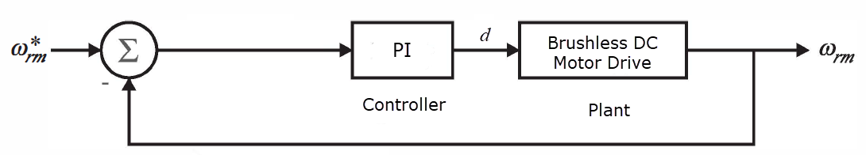

Figure 5 Close-loop control of the brushless DC motor for speed regulation

(1). You can use the example model – project_PI_example to tune PI controller parameters (integral and proportional parameters) by trial and error. The range of the integral parameter is from 1 to 50 while the proportional parameter is from 0.01 to 0.1. Report what parameter values you got for the PI controller to achieve fast and accurate speed regulation.

(2). To verify your speed controller is working properly, first at time zero, set the speed reference to be 600rpm and $T_{m}=1N∙m$. At 0.5 s, step down the rotor reference speed from 600rpm to 400rpm. Plot the stator currents , in one figure with two subplots, , , and in one figure, the motor torque in one figure, the motor speed $N$ rpm in one figure, and inverter output line to line voltage $v_{ab}$ from 0.85 s to 0.95 s in one figure. Comment what you have observed.

(3). Use the same PI controller for the **sine-triangle PWM modulated** three-phase inverter. The PI output will be send to the modulation index/peak value of the sine wave modulation signal. To verify your speed controller for sine-triangle PWM modulated three-phase inverter is working properly, firstly at time zero, set the speed reference to be 600rpm and $T_{m}=1N∙m$. At 0.5 s, step down the rotor reference speed from 600rpm to 400rpm. Plot the stator currents , in one figure with two subplots, , , and in one figure, the motor torque in one figure, the motor speed $N$ rpm in one figure, and inverter output line to line voltage $v_{ab}$ from 0.85 s to 0.95 s in one figure. Comment on what you have observed.

**Task 3: Use Simulink/Simscape/Power Systems/Specialized Technology to verify the design of the brushless DC machine drive system.**

In order to verify the brushless DC motor simulation model **using 180° modulation with the PWM** and the PI controller developed from the previous tasks, we would like to perform one simulation as follows.

(1). Start up the brushless DC motor from zero speed and assume the load torque to be $T_{m}=0.5N∙m$. Set the reference/command speed to be linear ramp-up function with the increasing rate of 500 rpm/second. When the speed reach 400 rpm, maintain the speed to be 400 rpm for 0.5 second.

(2). Continue from (1), step up the load torque $T_{m}$ from $0.5N∙m$ to $1N∙m$ instantaneously while keeping the speed reference to 400rpm. Run the simulation for 0.5 second.

(3). Continue from (2), step up the reference speed from 400 rpm to 600 rpm instantaneously while keeping the load torque $T_{m}$ to be $1N∙m$. Run the simulation for 0.5 second.

(4). Continue from (3), step down the load torque $T_{m}$ from 1 $N∙m$ to $-1N∙m$ instantaneously and keep the speed reference to be 600 rpm. Run the simulation for 0.5 second.

This emulates the regenerative mode. We assume motor convention for the brushless DC motor model meaning positive $T_{m}$ impedes the rotor rotation. Now when $T_{m}$ is negative, $T_{m}$ will be at the same direction of the rotor rotation. The motor torque $T_{e}$ impedes the rotor rotation. Thus the mechanical energy is fed back to the DC-link voltage source/battery.

(5). Continue from (4), ramp down the speed from 600 rpm to 138.5 rpm with the ramp rate of 500 rpm/second maintain the speed to be zero for 0.5 s. (Please explain if you can reduce the motor speed less than 138.5 rpm or not when $T_{m}=T_{e}=-1N∙m$? If you cannot, why? You can use the steady-state torque equation $T_{e}=\frac{3}{2}\frac{P}{2}\frac{λ_{m}r_{s}}{r_{s}^{2}+ω_{r}^{2}L_{ss}^{2}}(V_{qs}-\frac{ω_{r}L_{ss}}{r_{s}}V_{ds}-ω_{r}λ_{m})$ in which $V_{ds}=0$ due to the initial phase voltage $v_{as}$ angle $ϕ_{v}=0$. Note, given the negative $T_{e}=-1N∙m$, $V_{qs}$ should be smallest possible, i.e., zero to get the smallest rotor speed $ω_{r}$.

For the simulation performed above, please plot the following variables using Matlab plot function: the stator currents $i_{qs}$, $i_{ds}$ in one figure with two subplots, $i_{as}$, $i_{bs}$, and $i_{cs}$ in one figure, the line-to-line voltage $v_{ab}$ in one figure, the motor torque $T_{e}$ in one figure, the motor speed $N$ rpm in one figure, the PI controller output (the duty ratio *d*) and the DC-link current $i_{dc}$ in one figure. Comment on what you have observed.

**Task 4: Design the three-phase inverter for the brushless DC machine drive and size semiconductor components.**

(1) **Decide the rated DC link voltage for the sine-PWM modulated three-phase inverter.** In the previous tasks, we assume the DC-link voltage of the three-phase inverter is 72V and it works in the motor drive simulation. The question left for us, as the designers of the three-phase converter, is how to size the DC link voltage. If the DC link voltage is too low, the motor won’t get enough output voltage amplitude. However, if the DC-link voltage is too high, the semiconductor blocking voltage will be high which means higher cost and semiconductor losses. The method to calculate the required DC-link voltage is to check all the operating scenarios as below.

In order to obtain the peak motor torque $T_{e}=1N∙m$ or $T_{e}=-1N∙m$ in the full speed range from 0 to 600 rpm, calculate the required q-axis voltage $V_{qs}$, and then, **the amplitude of the fundamental frequency AC voltage $\sqrt{2}V_{s}$**  where $V_{s}$ is RMS value (as in Lecture 11 PPT), and lastly the DC link voltage $V_{dc}$ of the three-phase inverter.

(Hint: Use the torque equation in Lecture 11 PPT to calculate the require voltage $V_{qs}$ and $\sqrt{2}V_{s}$. (note: $V_{qs}=\sqrt{2}V_{s}$ since $ϕ_{s}=0$ as in Lecture 11 PPT). When $\sqrt{2}V_{s}$ is calculated, use $\sqrt{2}V_{s}=m_{peak}\frac{V_{dc}}{2}$ where $m_{peak}$ is peak value of the modulation signal (fundamental frequency AC signal) as given in Lecture 4 PPT.) Assuming $m_{peak}=1$, i.e., the peak value of the modulation signal is 1, we can calculate $V_{dc}$.)

You can write a Matlab program to calculate $V_{qs}$ and $V_{dc}$ automatically for the full speed range from 0 to 600 rpm with two torque values of $T_{e}=1N∙m$ or $T_{e}=-1N∙m$. **Please include the Matlab program for the $V_{qs}$ and $V_{dc}$ calculations in the report and plot the calculated $V_{dc}$ results for all the scenarios, i.e. plot (1) $V_{dc}$ vs. rpm from 0 to 600 rpm for $T_{e}=1N∙m$. (2) $V_{dc}$ vs. rpm from 200 rpm to 600 rpm for $T_{e}=-1N∙m$.** Are the $V_{dc}$ values less than 72V?

(2) Given the DC link voltage of 72V, the motor torque $T_{e}=1N∙m$ and motor speed 600 rpm, calculate the peak modulation signal $m_{peak}$ using $\sqrt{2}V_{s}=m_{peak}\frac{V_{dc}}{2}$. In the equation, $V_{dc}=72V$, $\sqrt{2}V_{s}=V_{qs}$ is known from the calculation in (1) given $T_{e}=1N∙m$ and motor speed 600 rpm. Compare the calculated $m_{peak}$ value with the simulated $m_{peak}$ in Task 2(3). Are they the same / can you verify it?